Assignment 10: Cyber Startup Business Plan
ZebrA Infiltrator
Teams: Web Penetration Testing & Red Team Report Issue Prioritization
Members: Nicole Cabezas, Cristian Contreras, Andrew Danda, Adil Ghoghawala, Joshua Godwin, Jack Jarjourah, Lalith Kothuru, Adrian Korwel, Albert Ly, Vincent Richardo & Darshan Sasidharan Nair
Executive Summary
ZebrA Infiltrator is an AI-driven web penetration test tool designed to identify and mitigate security vulnerabilities in web applications. Our mission is to provide businesses with a tool that can enhance their cybersecurity features. This plan will outline our value proposition, target market, competitive landscape, and financial projections regarding our growth and revenue potential.
Included in this document are other technical aspects of the project such as an overview of the web penetration test tool functions and strategic implementation.

Company and Management Team
Roles and Responsibilities:
Development Team: The Development Team designs, codes, and delivers our cybersecurity product, ensuring it meets the high standards and specialized needs of cybersecurity professionals. Their expertise drives innovation and reliability in securing digital environments.
- Adrian Korwel
- Darshan Nair
- Lalith Kothuru
- Joshua Godwin
- Andrew Danda
- Adil Ghoghawala
- Vincent Richardo
Business Operations and Strategy Team: This team oversees the company’s business functions, including marketing, finance, and administrative processes. They ensure smooth day-to-day operations, drive strategic growth and maintain alignment with organizational goals and market demands.
- Albert Ly
- Nicole Cabezas
Customer Experience and Compliance Team: This team focuses on delivering exceptional user experiences, ensuring intuitive design, and providing expert cybersecurity consulting and compliance services. They bridge the gap between client needs and product functionality, driving trust and satisfaction.
- Cristian Contreras
- Jack Jarjourah

Our Product
Description:
This product is an automated web penetration test tool that is designed to perform vulnerability scanning and provide detailed risk assessments. With this product’s first function, it will be able to scan a web application that a user inputs and look for any potential vulnerabilities present. Once these vulnerabilities are identified, and presented in a user-friendly dashboard, it gets parsed through separate tabs. This product’s secondary function is the usage of artificial intelligence (AI) in order to offer a comprehensive action plan containing costs, time, and skills needed to tackle the vulnerabilities found.
Value Proposition:
Our product offers businesses an automated web security testing tool that can accurately identify vulnerabilities and offer solutions towards resolving these vulnerabilities. Any vulnerabilities found will be given in visuals that will be comprehensive and easy to access through different tabs present in the website. With each high-priority vulnerability found, solutions conducted via AI will be generated and given towards users as suggestions on how to resolve such issues with their web application. This in turn saves these businesses time and money in researching ways to solve these issues on their own manually.
User Experience:
The user experience will comprise an interactive website with the ability to input website addresses for assessment. Once the user inputs a website address into the web penetration test tool, the tool will scan for any vulnerabilities present and offer visual data regarding any findings. Users will be able to click on separate tabs that detail information regarding the tested address such as vulnerabilities found, a system overview, and more.
Intellectual Property:
Our web penetration test tool uses proprietary algorithms utilizing AI in order to enhance detection accuracy and categorization. These algorithms, in particular, will utilize OpenAI’s ChatGPT 4o model as a method in which it generates suggested solutions towards any high-priority vulnerabilities found.
Risks and Mitigation:
Key risks include the potential for inaccurate results and the exposure of sensitive data during testing. To mitigate these, we ensure continuous updates and rigorous testing of both the front-end and back-end systems for improved accuracy and reliability. Additionally, our secondary function operates with a dedicated database, ensuring data security and minimizing the risk of leaks. This dual approach of constant monitoring and secure data management reinforces the reliability and confidentiality of our service.

Target Market
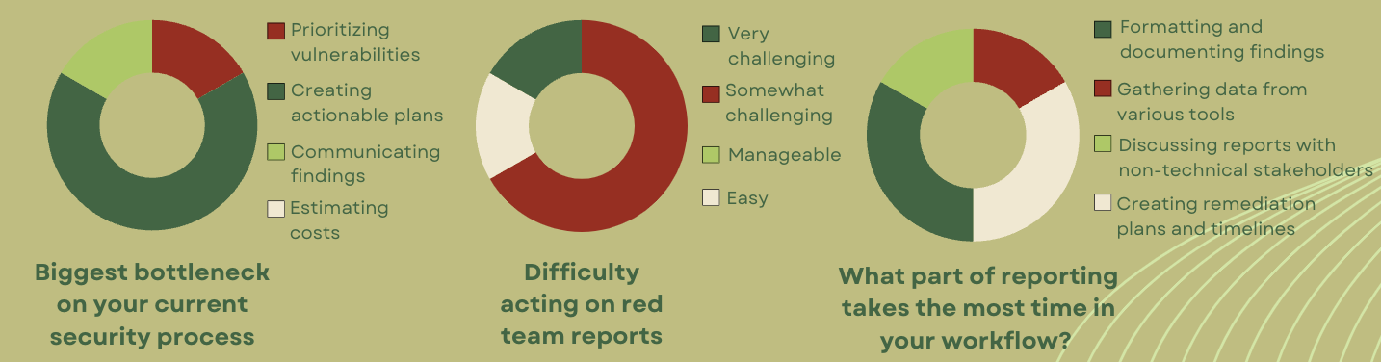
Needs:

According to primary data collected from our preliminary customer survey and secondary data from our research, cybersecurity professionals are in high demand due to the overwhelming workload they manage. Beyond identifying vulnerabilities to prevent attacks, they are often required to rewrite reports in a more accessible format for managers, resulting in duplicated efforts and extended working hours.

As shown in the figure above:
- 66.6% of respondents identified creating actionable plans as their biggest bottleneck.
- 17% and 67% found acting on red team reports either very challenging or somewhat challenging, respectively.
- 33.3% indicated that creating remediation plans, timelines, and formatting/documenting findings consumes most of their time.
Our customers need tools to optimize their time. To address this, our product is designed to meet their needs by automating repetitive daily tasks, saving valuable time and enhancing efficiency.

Market Size:
This is a medium-sized market segment with at least 71 cybersecurity penetration testing companies listed in The Manifest (a digital business guide to connect business with providers) just in the Chicago area. Additionally, Upwork lists at least 30+ freelance pen-testers in Chicago who are also potential customers. Assuming this as an average for cities in Illinois, this would put the Illinois market segment at at least 50K.
Target Customers:
Some of our customers are cybersecurity professionals, Penetration testers, IT security teams, Managed security service providers, C-suite executives, and Superiors/management receiving non-technical reports

Buyer Persona
Name:
Age: 25
Gender: Male
Education: Master´s
Income: $80,000 to $100,000 per year
Location: Chicago, IL
Job Title: Information Security Analyst
Industry: Technology
Goals:
- Protect digital assets from cyber threats
- Streamline vulnerability detection
- Communicate risks effectively to management
Challenges:
- Managing many security alerts
- Explaining technical issues to non-technical teams
- Staying ahead of evolving threats

Competitive Landscape
Overview:
The market for pen-testing tools is highly competitive, with many vendors offering similar features. This increases the pressure to differentiate our product through innovation, pricing, or service excellence. Thus, we aim to provide a unique solution by offering more than just vulnerability reports. Unlike traditional vulnerability scanning tools such as Rapid7, Ordr, and Nucleus Sec, which focus on identifying vulnerabilities and providing basic risk assessments, our product enhances the reporting process by offering prioritized action plans, complete with cost estimates for each vulnerability. This provides organizations with a clear, actionable strategy to address vulnerabilities, facilitating better decision-making for C-suite executives who may lack technical expertise.
- Option 1: Use Similar Programs:
Competitors like Rapid7, Ordr, and Nucleus Sec offer tools that provide management-friendly vulnerability reports. However, these tools generally lack the capability to prioritize vulnerabilities in a way that aligns directly with actionable steps for the organization’s risk management strategy. Our differentiation comes from offering a post-report solution that prioritizes vulnerabilities, generates a detailed action plan, and estimates the costs associated with remediation, which directly assists in budgeting and resource allocation.

- Option 2: DIY Approach
Another alternative for our market segment (highly capable pen-testers) is to continue using the reports they generate on their own, potentially without a clear follow-up plan. Pen-testers are skilled in identifying vulnerabilities but may lack the tools or time to translate these findings into actionable, prioritized plans. Our product is designed to complement these efforts, adding value by taking the technical report and enhancing it into a structured plan of action, complete with timelines and cost analysis, empowering organizations to make informed, educated decisions.
This strategic advantage, bridging the gap between technical vulnerability identification and executive action, is what sets our product apart from both existing tools and the DIY approach, making it an essential tool for companies looking to streamline their cybersecurity processes and ensure comprehensive risk management.

Advantages:
Our product leverages AI-driven automation to streamline penetration testing and vulnerability prioritization, making it faster and more accurate. The user-friendly web design ensures that both technical and non-technical users can easily navigate and understand the results. With proprietary technology, continuous updates, and regular audits, we provide consistent support to our users, ensuring the tool remains relevant and effective in addressing evolving cybersecurity challenges. These features combine to deliver a complete, scalable solution for businesses looking to enhance their security posture and decision-making processes.

Strategy and Implementation
Status and Traction:
The business is currently in the early idea and development stage, having successfully created a Minimum Viable Product (MVP) that showcases the core functionality and value proposition. While the MVP remains within a classroom setting, plans are underway to conduct a beta test as part of the Illinois Tech Innovation Day, fulfilling a requirement for the Ipro Class. This upcoming showcase will serve as the first opportunity to gather initial feedback and gauge user interest. At this stage, no external user feedback, demo sign-ups, or customer interest metrics have been collected. Completing the MVP stands as a significant early milestone, providing a solid foundation for further development and refinement based on anticipated feedback from the upcoming beta test.

Marketing Plan:
Our marketing plan consists of hosting digital campaigns, partnerships, webinars, and IT decision-maker outreach. As our product’s main features include scanning for vulnerabilities along with providing AI-generated solutions, we will present live demos of our product towards prospective customers in addition to providing video demos for playback of the product’s capabilities/functionality. With these demos in place, we hope to further expand our reach towards various businesses in need of a web penetration test tool that can provide comprehensive results and solutions.
Sales Strategy:
Sales Channels
- Online Self-Service:
  - Target: Smaller clients, including freelance pen testers and smaller cybersecurity firms.
  - Approach: These clients can sign up, demo, and purchase directly through an online platform, ensuring a seamless, low-touch buying experience.
  - Benefits: Self-service reduces sales costs and provides a scalable method for onboarding a large number of smaller clients efficiently.
- Direct Sales:
  - Target: Larger enterprise clients with complex needs, such as big corporations and cybersecurity firms with extensive security requirements.
  - Approach: Enterprise clients will receive a more personalized approach through direct outreach, custom demos, and tailored onboarding.
  - Benefits: Direct sales allow for relationship-building and provide a customized experience to high-value clients, supporting long-term contract sales and retention.
Customer Journey
Awareness and Initial Contact:
- Customers discover the product through networking, industry events, or online promotions. They are directed to the website to learn more.
Demo or Free Trial:
- Self-Service Demo for Smaller Clients: A self-guided demo or short free trial is available to showcase the product’s simplicity and key features.
- Personalized Demos for Enterprise Clients: For larger clients, direct sales offer tailored demos that highlight executive-friendly reporting and ease of use.
Evaluation and Engagement:
- Users engage with the product to understand how it fits into their workflow. Smaller clients rely on self-guided resources, while enterprise clients have a sales representative for additional support.
Purchase and Onboarding:
- Self-Service: Smaller clients complete purchases through an online checkout process.
- Direct Sales: Enterprise clients finalize contracts with assistance from the sales team, and custom onboarding can be provided as needed.
Ongoing Engagement and Support:
- Customers receive ongoing support through automated emails, chatbot assistance, and a knowledge base. Enterprise clients have a dedicated point of contact for high-touch support.
Sales Tactics for Key Segments
For Enterprise Clients:
- High-Touch Sales Approach: Emphasize a consultative, relationship-driven approach with tailored demos that showcase the product’s unique ability to provide clear, actionable insights for executive stakeholders.
- Focus on Time Savings: Demonstrate how the tool reduces engineers’ time explaining technical details to executives by simplifying complex reports.
- Custom Contracts: Offer long-term contracts with lump-sum payments, allowing for secure, predictable revenue and aligning with enterprise purchasing preferences.
For Freelancers and Small Firms:
- Self-Service Model: Provide a self-guided online demo or free trial where smaller clients can independently explore the product’s benefits.
- Cost-Effective and Flexible Plans: Highlight flexible pricing tiers and ease of use, making the product attractive for smaller budgets.

Pricing and Contract Strategy
- Long-Term Contracts with Lump-Sum Payments: Aimed at enterprise clients, these contracts provide stable revenue and enable resource allocation to further product development and customer support.
- Tiered Subscription Model for Smaller Clients: Different plans for freelancers, small businesses, and consulting firms ensure pricing flexibility and accessibility across segments.

Onboarding and Support Process
Personal Onboarding for Enterprise Clients:
- Founder-Led Training: Founders or senior team members conduct onboarding sessions for enterprise clients, showcasing the tool’s time-saving features and addressing specific needs.
- Customized Onboarding: Tailored onboarding plans align with each enterprise client’s requirements, addressing integration and operational fit.
- Follow-Up Support: Scheduled follow-ups provide additional support as enterprise clients start using the product.
Self-Service Onboarding for Smaller Clients:
- Video Tutorials and Knowledge Base: A library of video tutorials and articles enables users to quickly learn the tool independently.
- Chatbot Assistance: A chatbot offers real-time guidance, especially useful during the initial setup phase.
- Automated Email Sequence: New clients receive a series of emails introducing them to essential features and best practices.

Key Sales Metrics and Goals
Customer Acquisition:
- Goal: Acquire 5-10 new self-service clients monthly and onboard 1-2 new enterprise clients quarterly as relationships and credibility grow.
Conversion Rates:
- Goal: Achieve a 10-15% conversion rate from demo participants to paying customers, with a higher rate expected among enterprise clients due to tailored demos.
Average Revenue per Customer (ARPC):
- Target: Smaller clients at $500-$1,000 per month, with significant contributions from enterprise contracts through lump-sum payments.
Customer Retention Rate:
- Goal: Maintain an 85% retention rate or higher, ensuring high engagement and loyalty.
LTV to CAC Ratio:
- Goal: Aim for a 3:1 ratio, meaning each customer generates three times the acquisition cost, a common benchmark for sustainable growth in cybersecurity.

Sales Team Structure and Scalability Plan
- Initial Phase: Founder-led sales for high-touch enterprise deals and minimal support needs for self-service clients.
- Future Expansion: As the customer base grows, introduce a dedicated customer success or account management role to handle onboarding, support, and upselling opportunities for enterprise accounts.

Milestones
Product Development
- Months 1-3: Complete beta testing, refine MVP features based on feedback.
- Months 4-6: Release feature updates, improve integration with vulnerability assessment tools.
- Months 7-9: Add localization and customization options for enterprise clients.
- Months 10-12: Optimize product scalability and plan additional features.
Sales and Customer Acquisition
- Months 1-3: Acquire initial beta clients; focus on 5-10 small clients/month.
- Months 4-6: Increase small client acquisition to 10/month; target 1-2 enterprise clients.
- Months 7-9: Grow monthly small client acquisition by 20%; add 1-2 enterprise clients quarterly.
- Months 10-12: Focus on contract renewals and finalize contracts with 1-2 more enterprise clients.
Marketing and Brand Awareness
- Months 1-3: Launch brand awareness campaigns via networking and industry events.
- Months 4-6: Start webinar series for cybersecurity professionals and executives.
- Months 7-9: Partner with influencers, expand social media presence.
- Months 10-12: Build brand visibility at conferences, showcase success stories.
Customer Success and Support
- Months 1-3: Develop onboarding resources (videos, knowledge base, chatbot).
- Months 4-6: Structure onboarding for enterprise clients with personalized support.
- Months 7-9: Track customer satisfaction, conduct check-ins for enterprise clients.
- Months 10-12: Maintain 85%+ retention, identify up selling opportunities.
Metrics and Performance Tracking
- Months 1-3: Set baseline metrics, track demo sign-ups and conversions.
- Months 4-6: Monitor customer acquisition, ARPC, and retention.
- Months 7-9: Adjust targets based on initial data, assess upselling trends.
- Months 10-12: Conduct quarterly reviews, refine sales and marketing strategies.
Funding and Financial Planning
- Months 1-3: Create financial projections based on beta feedback.
- Months 4-6: Evaluate funding needs for scaling, allocate budget.
- Months 7-9: Secure additional resources as the client base grows.
- Months 10-12: Finalize funding and resource plans for continued scaling.

Funding Needs and Use of Funds (Inspired by CrowdStrike's Growth Model):
- Example Company: CrowdStrike Holdings, Inc.
  - CrowdStrike, a prominent cybersecurity company specializing in endpoint security, was founded in 2011. In its early years, CrowdStrike raised funds through seed and Series A rounds, enabling rapid product development and brand building. By targeting enterprises with high cybersecurity needs, they quickly established a strong market presence and expanded globally. Key points from CrowdStrike's early strategy provide a foundation for structuring your funding approach.

  - Funding Needs: To replicate the growth and structure seen in CrowdStrike's early model, the business would aim to raise an initial seed fund to build product capability and market presence. CrowdStrike raised $25 million in its Series A, setting the stage for aggressive expansion. While your target funding would be more modest, focusing on product development, sales, and brand presence will yield similar benefits.
    - Total Funding Goal: Approximately $200,000 - $300,000
      - Goal: This level of funding supports product development, targeted marketing, and initial sales efforts, similar to CrowdStrike’s early emphasis on product-market fit and scalable sales.
    - Funding Stages:
      - Seed Round: Seek funding from angel investors or venture capitalists with a focus on cybersecurity. This funding can be used to establish the MVP’s market viability and achieve initial customer traction.

Financials
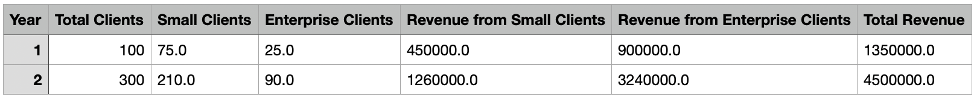
Projections:

The revenue projections were based on several key assumptions. First, it was assumed that 100 clients would be acquired in year 1, with a growth to 300 clients in year 2. For the distribution of clients, 75% of the clients in year 1 and 70% in year 2 were assumed to be small clients, while the remaining percentage were enterprise clients. The average revenue per customer (ARPC) for small clients was set at $500 per month, with enterprise clients generating $3,000 per month. It was assumed that clients would stay for a full year, with the annual revenue calculated accordingly. These assumptions aim to capture initial traction with small clients and a gradual shift toward more significant enterprise contracts as the business scales.

Revenue Model:
Subscription Model
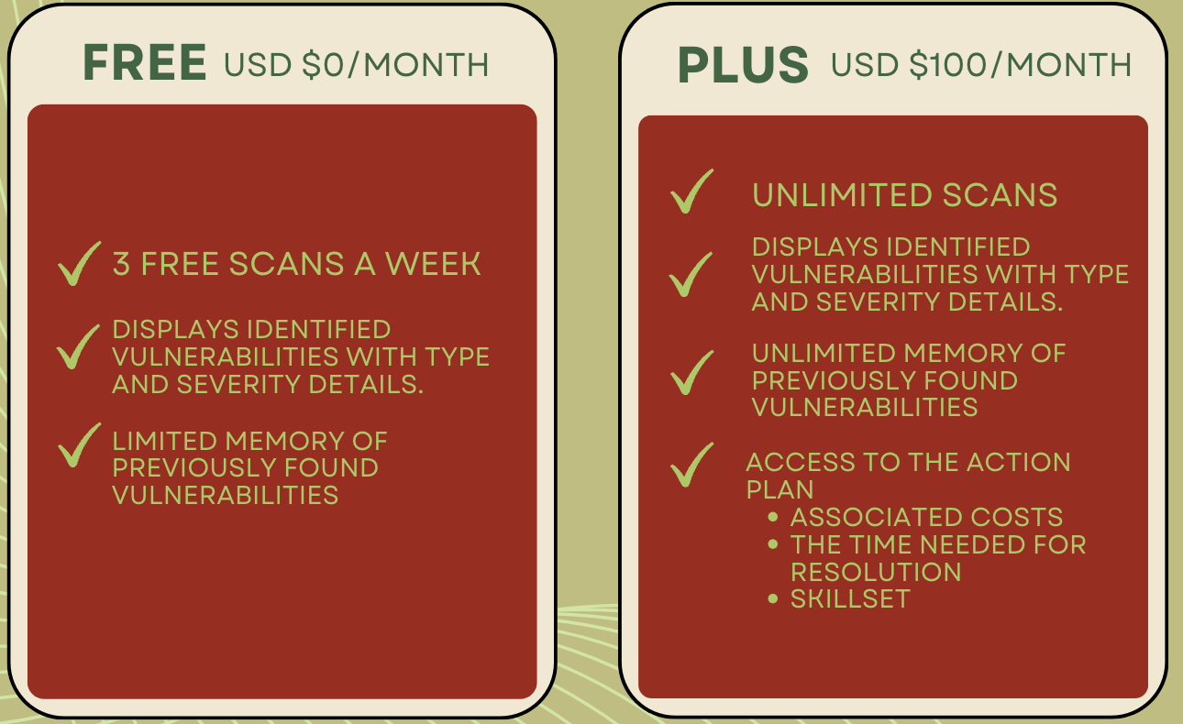
  - Plus Version. will have unlimited access and be able to access secondary feature
  - Free Version will be limited to three scans and are unable to access secondary feature
  - Enforced by account identification (Account req. to perform a scan)
Appendices
Reference(s):
- https://drive.google.com/file/d/16IQMKNf-ysVfJvQuGSgzDeAcvVKxd1oz/view?usp=sharing

